Purpose

This experiment was conducted to investigate how density can be measured and the relationship density has with mass and volume.

Materials

1. Graduated cylinder
2. Solid test tube stopper
3. Ball bearing
4. Water
5. Gram scale
6. Notebook

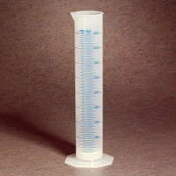

Figure Graduated cylinder

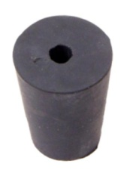

Figure Test tube stopper

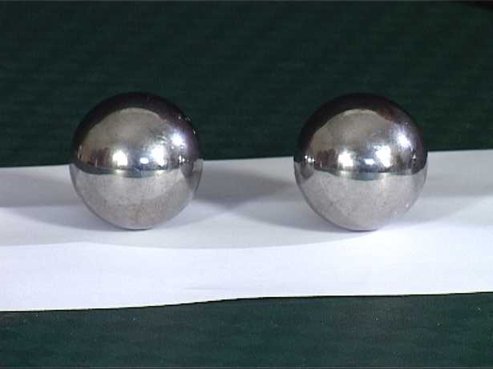

Figure Ball bearing

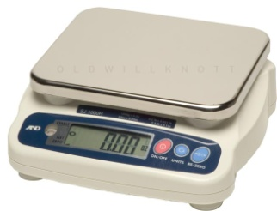

Figure Gram scale

Experiment Matrix

Part A:

Weigh the solid test tube stopper using the gram scale. Record the measurement in the notebook.

Fill the graduated cylinder with 50 ml of water.

Carefully drop the test tube stopper in the graduated cylinder.

Record the amount of ml of water in the test tube.

Calculate the density of the test tube stopper. Record the density in g/ml.

Part B:

Weigh the solid ball bearing using the gram scale and record the measurement in the notebook.

Fill the graduated cylinder with 50 ml of water.

Carefully drop the solid ball bearing in the graduated cylinder.

Record the amount of ml of water in the test tube in the notebook.

Calculate the density of the ball bearing. Record the density in g/ml.

How to Calculate Density:

Weight of object dropped/Final volume in the cylinder - initial volume in cylinder

Data

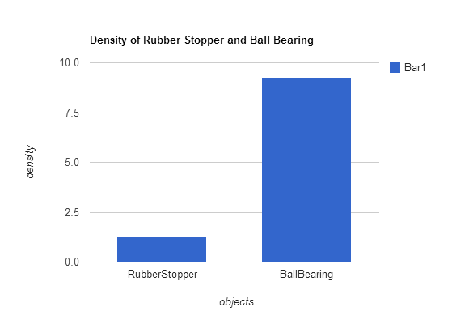

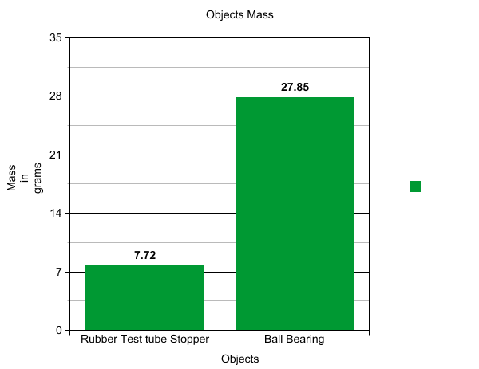

|  |  |  |
| --- | --- | --- |
|  | Density | Mass |
| Rubber Stopper | 1.286666667 | 7.72 grams |
| Ball Bearing | 9.28333333 | 27.85 grams |

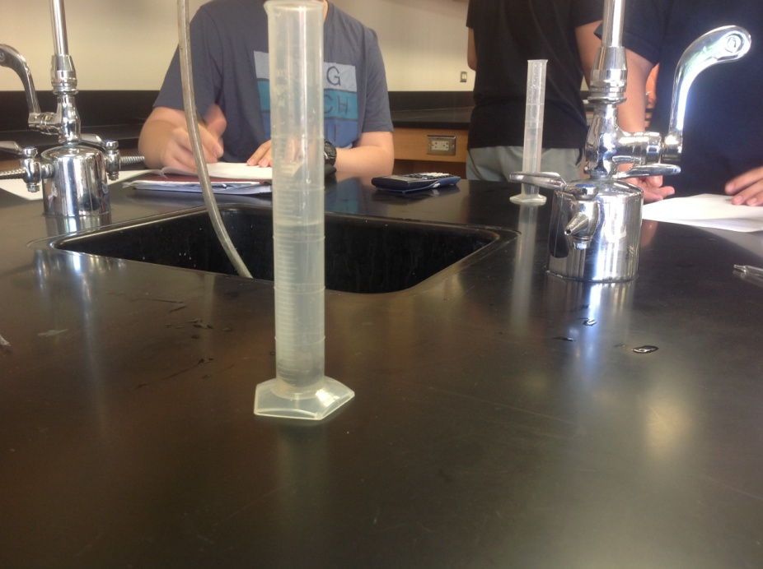

Conclusion:

The ball bearing was denser and had more mass than the rubber stopper which had less mass and also was less dense.

In response to question 1 the unknown liquid is Xylene and it has a density of 861 kg/m^3

The Principle of Archimedes relates to density because it can be used to determine the density of an object. The weight of an object and the weight of an object in water is used to determine density using the Principle of Archimedes.